2025 TAYC Annual Regatta
The Tred Avon Yacht Club Annual Regatta was held August 9th and 10th, 2025. 11 Penguins were on the starting line for the 4 race series. Winds were light out of the northeast with buig shifts. PRO Bill Wade set a reasonably square starting line and the shifts tended to average out, only necessitating one windward mark move. However, on the race course, it was not so simple finding wind lines or avoiding the big holes that dotted the race course. Bill Lawson and Colette Preis were the most consistent in the tricky conditions to end Saturday with 11 points, followed closely by Jonathan and Annie Bartlett with 12 points. Bob and Nora Beck Tan and Charlie and Cairn Krafft were 4 points back and tied for third. Ginny Mininger and Sarah Russell, in their Penguin debut had a 2nd and 4th place finish, but an early start in the final race was too hard to recover from, leaving them in 5th. Spencer McAllister sailing with his almost 5 year old son, Jack, in Jack’s first regatta, finished 6^{th.} They were joined in a least one race by Jack’s younger sister, Maive, also first time racing. Patrick Brooks sailed with his son Bennett. The parent child theme was repeated with Gray and Graham Shannahan, and Seth and Beatrice Mininger. Mike Baugh, who often sails with one of his two sons, was instead joined by his wife Sarah, as their boys were racing Optis. It was good to see Wick Dudley back in his Penguin, which has been in storage for many years. Wick won the William and Alice Lane Classic Penguin Perpetual. Will Keyworth was on hand an captured some great photos, which can be seen at the spinsheet.com/photo-galleries web page.
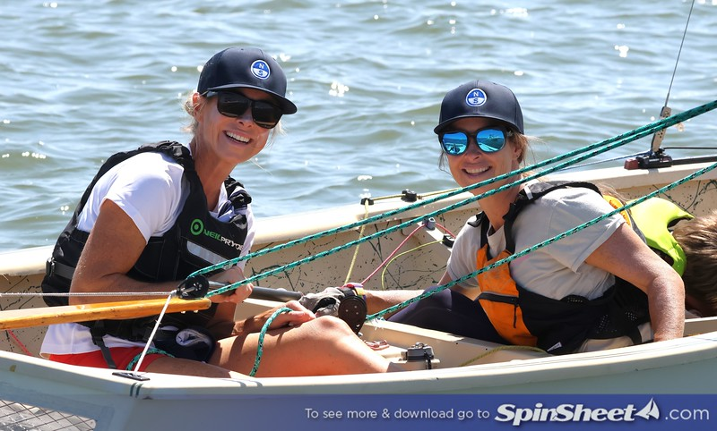
Ginny Mininger and Sarah Russell – first time racing a Penguin. Photo by Will Keyworth.
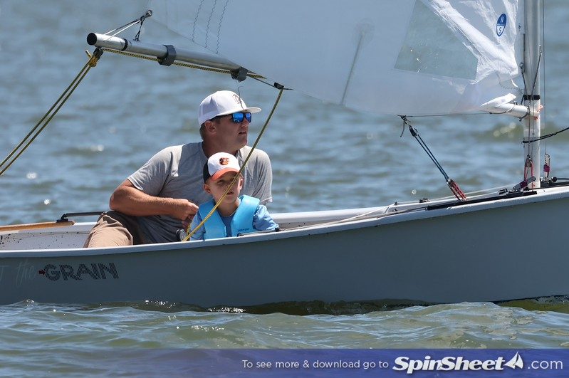
Spencer and Jack McAllister. Jack’s first Penguin regatta. Photo by Will Keyworth.
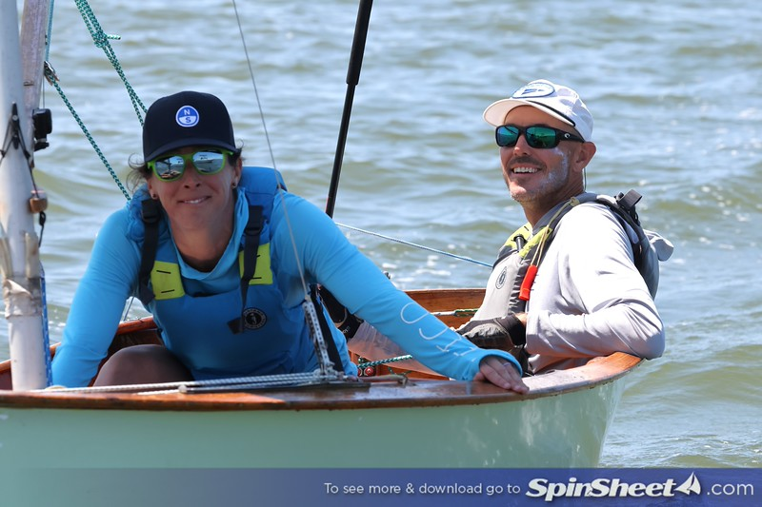
Mike and Sarah Baugh. Photo by Will Keyworth.
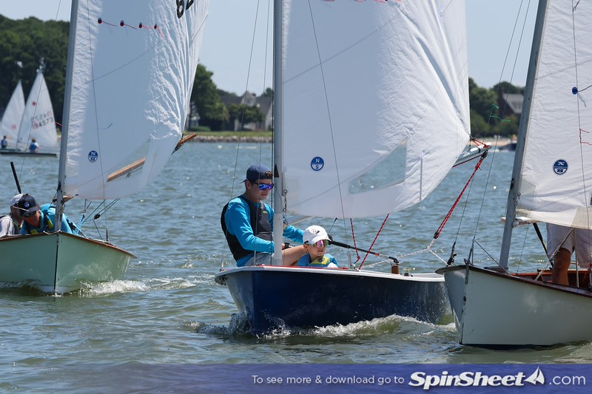
Gray and Graham Shannahan giving room at the mark. Racing was very close. Photo by Will Keyworth.
 | Sailors | Sail Number | Boat Name | Club/Org | Net | Total | R1 | R2 | R3 | R4 | R5
1 | William Lawson  Colette Preis | USA 9677 | Family Ties | SSA | 11 | 11 | 4 | 4 | 2 | 1 | -
2 | Jonathan Bartlett  Annie Bartlett | USA 9660 | Sister Mary Stigmata | Annapolis Yacht Club | 12 | 12 | 2 | 1 | 3 | 6 | -
3 | Charles Krafft  Cairn Krafft | USA 9694 | Otter B | SSA | 16 | 16 | 8 | 5 | 1 | 2 | -
4 | Bob Tan  Nora Beck Tan | USA 9669 | Ugly Duckling | SSA | 16 | 16 | 1 | 3 | 7 | 5 | -
5 | Ginny Mininger  Sarah Russell | USA 9668 | MOMMY ISSUES | TAYC | 21 | 21 | 5 | 2 | 4 | 10 | -
6 | Spencer McAllister  Jack McAllister | USA 9662 | Against the Grain | TAYC | 26 | 26 | 3 | 6 | 10 | 7 | -
7 | Patrick Brooks  Bennett Brooks | USA 9663 | None | TAYC | 27 | 27 | 7 | 9 | 8 | 3 | -
8 | Wick Dudley | USA 8909 | No Clew | Corsica River YC | 29 | 29 | 6 | 10 | 9 | 4 | -
9 | Gray Shannahan  Graham Shannahan | USA 9680 | Bandit | Linstead Sailing Club | 31 | 31 | 10 | 8 | 5 | 8 | -
10 | Seth Mininger  Beatrice Mininger | USA 6945 | PssFly | TAYC | 33 | 33 | 9 | 7 | 6 | 11 | -
11 | Michael Baugh  Sarah Baugh | USA 8241 | Humble Pie | Tred Avon Yacht Club | 42 | 42 | 11 | 11 | 11 | 9 | -

